Below is a typical traditional way. I will want to turn it into a dynamic dashboard. There are further details as we go to the next level (all companies details, projects, financials, progress, etc.).  Can be a progressive projects over a few batches.

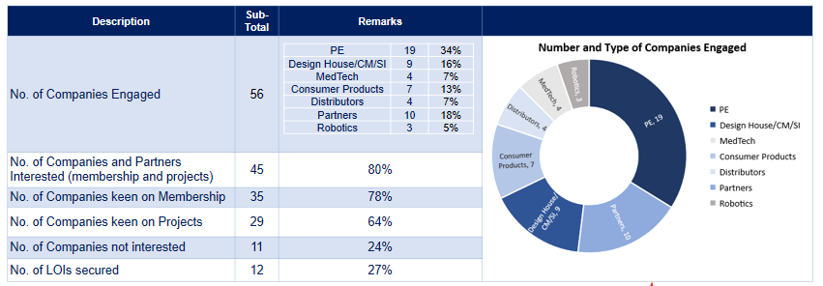

Rayner: <Rayner_Ng@simtech.a-star.edu.sg>